**7 Segment LED**

Seven segment displays are widely used in electronic devices, these are user interfacing display devices used to display numeric digit/number. Seven Segment consists of 7 LEDs and combination of LEDs can display a digit from 0 to 9 as shown in figure below.

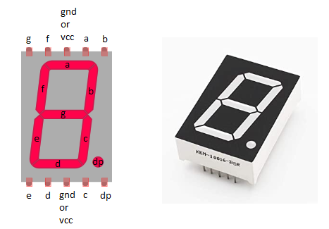

We can see in figure we have 7 Leds from a to g and one additional decimal point(dp) Led. We don't need dp led to display a number and we will keep this aside in our further discussion. If we turn on all LED’s except g then zero is displayed, if we turn on all LED’s eight is displayed similarly we can display any digit from 0 to 1. We have pins in middle to connect to GND or VCC.

**There are basically 2 types of 7 segment LED display:**

**Common Anode:** All the Negative terminals (Anode) of all the 8 LEDs are connected together. All the positive terminals are left alone.

**Common Cathode:** All the positive terminals (Cathode) of all the 8 LEDs are connected together. All the negative thermals are left alone.